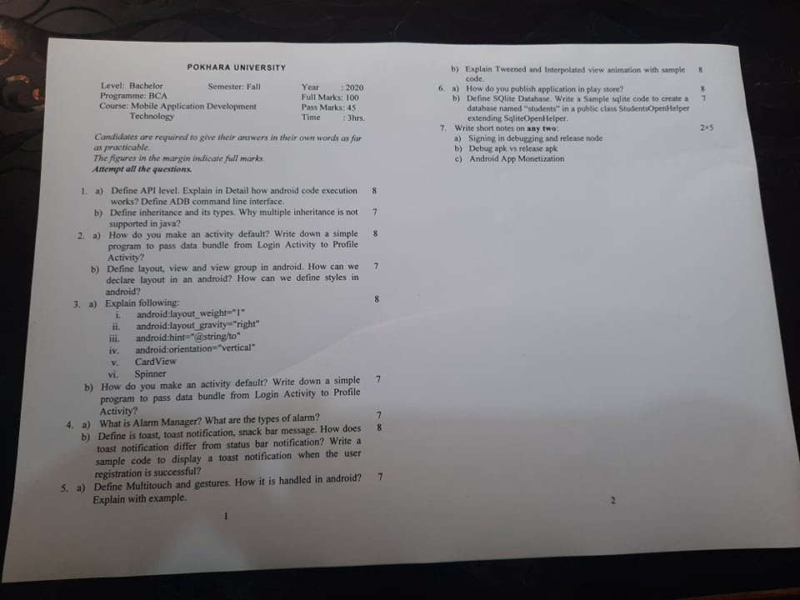

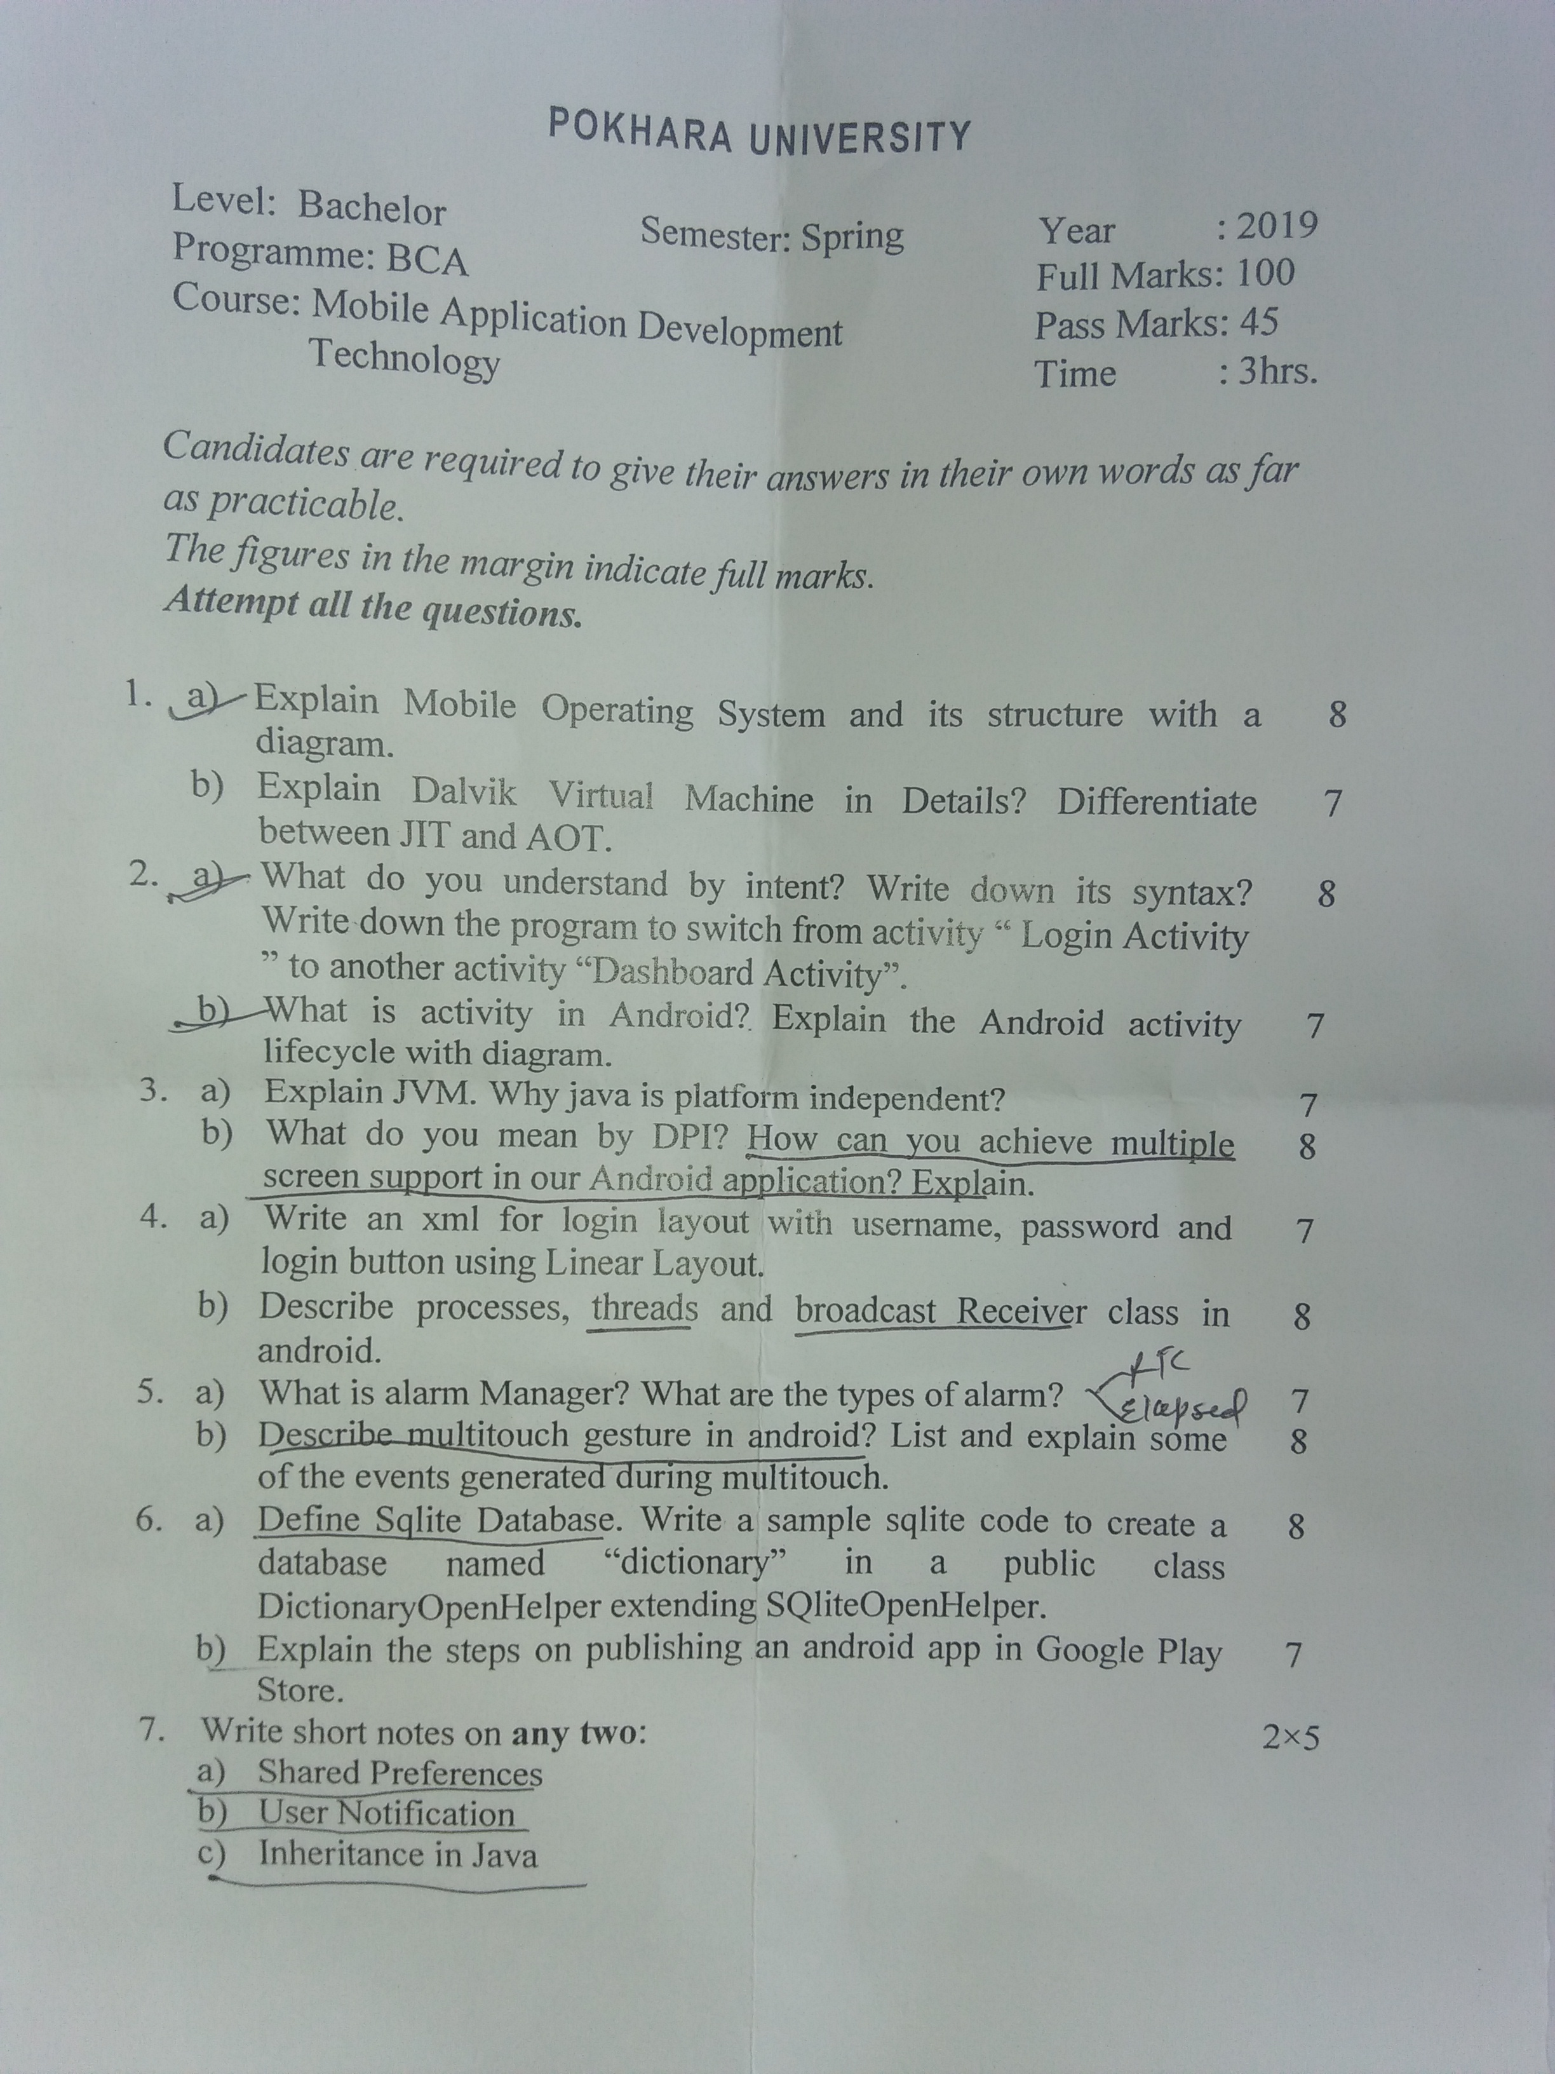

POKHARA UNIVERSITY
Semester: Fall
Level: Bachelor Year: 2017
Program: B.C. A. Full Marks: 100
Course: Android Development Programming Technology Time: 3hrs
Candidates are required to give their answers in their own words as far as practicable.
The figures in the margin indicate full marks.
Attempt all questions.
1 a) What is android? Write brief history of Android. 8
b) List android API versions. What is the latest Android API version? What API version should your app would need to support maximum users? Explain. 7
2 a) What do you understand by Intent? Write down its Syntax. Write down the program to switch from activity "LoginActivity" to another activity "DashboardActivity". 8
b) What is activity in Android? Explain the Android activity life-cycle with diagram. 7
3 a) What do you understand by views in Android? Explain the following. 8
i. EditText
ii. Spinner
iii. Progress Bar
iv. Orientation in Linear Layout
b) How to work with multiple screens in Android? Explain with use cases as possible 7
4 a) Write down the advantages and disadvantages of Android operating System. Explain alert Dialog Box. 8
b) Explain the following properties of views 7
i. android:visibility="gone"
ii. android:text="@string/Login"
iii. android:layout_width="match_parent"
iv. android:hint="@string/Address"
v. android:layout_height="wrap_content"
vi. android:textColor="@color/black"
vii. android:inoutType="phone"
viii. android:id="@+id/etxtMobileNumber"
ix. android:gravity="center"
x. android:backgroung="@color/green"

5 a) Write down the xml for following using relative layout. 8
Enter first name
Enter last name
Desired username
Password
Re-enter password
Enter valid email is (optional)
Register
b) Which would you prefer database or shared preferences for persistence storage.
6 a) Write code for button click listener to switch to another activity. 7
b) What is Toast Notification? How does it differ from status bar Notification? Write a simple code to display toast Notification when an activity is started. 8
7 Write short note on (any two) 5x2 = 10
a) Google Paly Services
b) Debug apk vs Release apk
c) Android App Monetization

POKHARA UNIVERSITY
Semester: Spring
Level: Bachelor Year: 2016
Program: B.C. A. Full Marks: 100
Course: Android Development Programming Technology Time: 3hrs
Candidates are required to give their answers in their own words as far as practicable.
The figures in the margin indicate full marks.
Attempt all questions.
1 a) What are different mobile Oses? Explain in brief one of the popular mobile OS with its architecture. 1+7
b) Draw the architecture diagram of Android Runtime. 7
2 a) Differentiate between class and object with real world scenario, create class, instantiate object and explain them. 2+6
b) What are the features of OOPs. How do you achieve polymorphism in Java? 2+5
3 a) What is intent in android? What are different kinds of intents supported by android? 3+5
b) Design a basic android manifest file and explain the use of it. 7
4 a) How do you create the User Interface in native Android? Explain how these interfaces are bounded with activity? 2+5
b) Give a brief overview of multiscreen support. What are the underlying factors that needs in consideration while designing multiscreen support?
OR
Write a program (activity, layout) in native android for “signup process” with assumption from any social media. 7
5 a) What is notification? Explain the importance of thread in notification? 3+5
OR
What is push notification? Explain the Google Cloud Messaging System.
b) What is multi touch gesture in android? List and explain some of the events generated during multitouch. 2+5
6 a) What is shared preferences? Explain inbuilt database in android. 3+5
b) List and Explain the steps involved in publishing an app in play store starting from source code. 7
7 Write short notes on: (Any two) 2x5 =10
- ADB
- Fragment
- AsyncTask

